Question: How effectively can modern genomic and single-cell technologies capture the complexity of intratumour heterogeneity, and what are the implications for biomarker discovery and therapy resistance?
Intratumour heterogeneity (ITH) describes the presence of genetically, epigenetically, transcriptionally, and phenotypically distinct cell populations within a single tumour. Across 2,658 human cancers, 95.1% of informative samples contained subclonal expansions, indicating continual tumour diversification rather than uniform growth.¹ In TRACERx, analysis of 947 tumour regions linked subclonal chromosomal instability and whole-genome doubling with recurrence in non-small-cell lung cancer, while transcriptomic variation contributed to tumour evolution.^{2,3} Pan-cancer whole-genome comparison of primary and metastatic solid tumours showed that metastatic tumours are more clonally restricted than primaries, reinforcing selection during spread.⁴ ITH therefore defines how tumours progress, evade treatment, and undermine biomarker discovery.
Modern genomic technologies capture ITH at the level of clonal composition, but only within the limits of sampling. Bulk sequencing identifies dominant drivers, yet it averages mixed populations and can miss low-frequency or spatially restricted subclones, whereas single-cell approaches resolve cellular diversity but introduce technical noise and dropout.⁵ Although single-cell approaches can infer clonal relationships, limited sequencing depth and spatial discontinuity reduce confidence in reconstructing evolutionary hierarchy. In breast cancer, single-cell genome sequencing revealed pervasive copy-number heterogeneity that bulk sequencing would collapse into a composite signal, showing coexisting genomic states.⁶
Single-cell transcriptomics captures cellular state and functional plasticity. In melanoma, single-cell RNA sequencing (scRNA-seq) showed that resistance to MAPK inhibition was associated with tumour-intrinsic inflammatory signalling, particularly interleukin 6 (IL6) and tumour necrosis factor alpha (TNF-alpha), rather than dedifferentiation alone.⁷ In a separate melanoma scRNA-seq study, a poorly metastatic cell line and its high lung and brain metastatic subclones revealed a metastasis-associated transcriptional signature with prognostic implication, demonstrating resolution of pre-metastatic states.⁸ In large lung cancer, RNA-level variation, including allele-specific expression and RNA editing, contributes to tumour evolution.³ Similarly, single-cell analysis of oesophageal squamous-cell carcinoma shows diverse malignant, immune, and stromal populations organised into distinct transcriptional programmes and interaction networks rather than uniform cell populations.⁹ Although these approaches define cell states, they cannot reconstruct clonal lineage relationships or temporal evolution. Transcriptomic heterogeneity arises from RNA-level processes such as ADAR and APOBEC activity, while sampling bias limits detection of spatially restricted populations (Figure 3).^{3,10} Pan-cancer atlases show that resistant transcriptional programmes recur across tumours, but recurrence alone does not reveal which cell populations drive disease.¹⁰ Transcriptomic approaches therefore capture phenotypic heterogeneity but cannot determine subclonal drivers of disease progression.
These limitations are most evident in biomarker development. In metastatic castration-resistant prostate cancer, 27% of biopsies show no detectable prostate-specific membrane antigen (PSMA) expression, while 84% of PSMA-positive biopsies contain heterogeneous PSMA-negative regions within the same sample.¹¹ A single positive biopsy therefore does not ensure uniform target coverage, and a negative biopsy may reflect undersampling rather than true absence. In colorectal cancer, spatial transcriptomics shows consensus molecular subtype (CMS) 3 localisation in non-neoplastic mucosa and CMS4 in stroma-rich regions, while bulk RNA-based or deconvolution-based classification misclassifies mixed lesions by averaging distinct compartments.¹² A recent liquid biopsy study in hard-to-biopsy cholangiocarcinoma and urothelial tract cancer showed that parallel scRNA-seq of exfoliated tumour cells improved diagnosis and mutation recovery when compared with cell-free DNA (cfDNA) alone, with bile-based cholangiocarcinoma detection reaching 96% sensitivity and 100% specificity versus 13% sensitivity for bile cfDNA copy-number alteration (CNA) profiling and 56% for pathological evaluation, and urine-based upper tract urothelial carcinoma detection reaching 90% sensitivity and 100% positive predictive value versus 40% for biopsy-based pathology and 10% for urine cytology.¹³ Biomarker validity therefore depends on spatial fidelity, reproducibility, and performance under clinical sampling conditions rather than controlled datasets. Longitudinal genomic profiling in ROS1-positive lung cancer further shows that circulating tumour DNA can identify emerging resistance mutations and clonal evolution under targeted therapy, although detection remains limited by tumour burden and assay sensitivity.¹⁴
This gap between detection and utility is demonstrated in clinical sequencing studies. In SAFIR01, genomic profiling identified targetable alterations in 46% of metastatic breast cancer patients, yet only 13% were matched to targeted therapy, and objective responses were limited.¹⁵ This shows that detection, clonality, druggability, and treatment response are independent variables. Increasing sequencing depth does not resolve this unless the alteration is truncal and functionally dominant, a point reflected in clinical trials that increasingly use longitudinal and multimodal sequencing, underscoring the inadequacy of time-point profiling (Table 1).
ITH also drives therapy resistance through evolutionary selection. In small-cell lung cancer, first-line platinum-based chemotherapy increases genomic heterogeneity and induces branched evolution from ancestral clones, with relapse driven by subclones derived from a common ancestor.¹⁶ In melanoma, resistance emerges through expansion of treatment-tolerant cell states during targeted therapy, showing that phenotypic plasticity contributes to survival.^{7,16} This reflects Darwinian selection, where treatment enriches pre-existing lineages with fitness advantage rather than generating resistance de novo.¹⁷ Consequently, relapse reflects evolutionary selection rather than treatment failure alone. In neuroblastoma, spatial and temporal heterogeneity in anaplastic lymphoma kinase (ALK), fibroblast growth factor receptor 1 (FGFR1), and BRAF alterations means single biopsies can miss or overestimate the clone responsible for relapse, reducing diagnostic precision.¹⁸ In melanoma, resistance is not determined solely by cell state, as dedifferentiated cells are not intrinsically resistant to BRAF and MEK inhibition. Instead, tumour-intrinsic IL6 and TNF-alpha signalling sustain survival under treatment.⁷ Resistance is therefore better defined as a dynamic ecosystem process rather than a fixed mutation profile.
The clinical trials show how the field is attempting to address these limitations (Table 1). Trials such as NCT05303480 incorporate multimodal profiling, while NCT04008238 and NCT06861647 use longitudinal tumour and circulating DNA sequencing to capture temporal evolution.¹⁹⁻²¹ NCT01970865 integrates tissue and plasma sequencing to monitor resistance in real time.²² These studies do not demonstrate improved outcomes, but show a shift towards serial, multi-site, and multi-omic sampling. This shift reflects recognition that heterogeneity is dynamic and cannot be captured by static profiling.
Overall, modern genomic and single-cell technologies detect ITH and identify genomic and transcriptomic components. They are not sufficient for clinical decision-making, as they incompletely resolve spatial, temporal, and functional dynamics and remain influenced by platform-specific biases.⁵ No single technology fully captures ITH, and clinical interpretation requires integration of genomic, transcriptomic, spatial, and longitudinal data rather than reliance on a single platform.
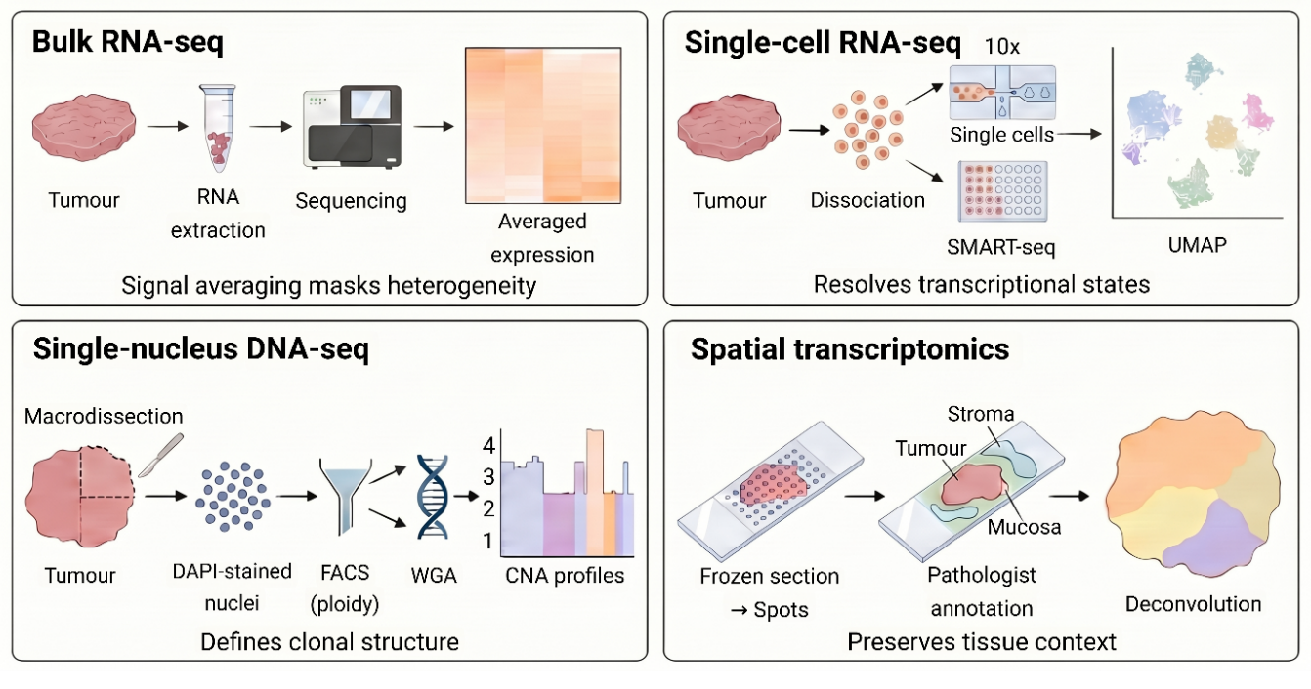
Figure 1. The top left shows bulk RNA sequencing (RNA-seq), where ribonucleic acid (RNA) is extracted and sequenced, resulting in averaged tumour signals that mask subclonal diversity. The top right shows single-cell RNA sequencing (scRNA-seq), where tumour tissue is dissociated into individual cells and processed using methods such as SMART-seq (Switching Mechanism at the 5′ end of RNA Template sequencing), allowing resolution of transcriptional states that are commonly visualised using uniform manifold approximation and projection (UMAP). The bottom left shows single-nucleus DNA sequencing, in which nuclei stained with 4′,6-diamidino-2-phenylindole (DAPI) are isolated and sorted by fluorescence-activated cell sorting (FACS) based on ploidy, followed by whole genome amplification (WGA) and copy-number alteration (CNA) profiling to define clonal structure. The bottom right shows spatial transcriptomics, where frozen tissue sections are analysed using spot-based sequencing alongside histopathological annotation to preserve tissue architecture and regional transcriptional programmes. Adapted from ^{5,6,12}.Created in BioRender.com.

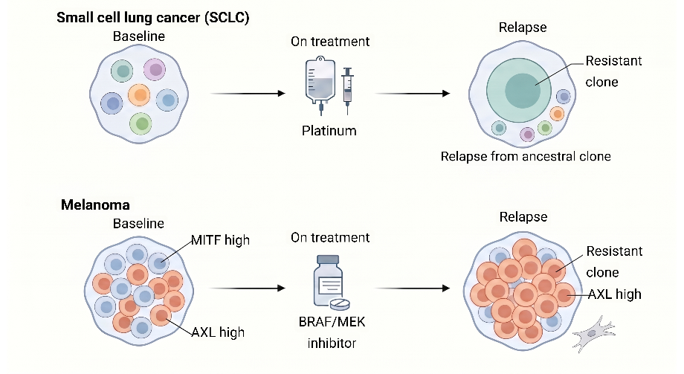
A
B

Figure 2. Evolutionary dynamics of therapy resistance driven by intratumour heterogeneity. (A) In small-cell lung cancer, platinum chemotherapy selects resistant subclones derived from a common ancestor. (B) In melanoma, BRAF (v-raf murine sarcoma viral oncogene homolog B1)/MEK (mitogen-activated protein kinase kinase) inhibition selects for treatment-tolerant populations, while single-cell RNA sequencing reveals pre-existing transcriptional states associated with metastatic potential. Adapted from ^{7,8,15,16}. Created in BioRender.com.

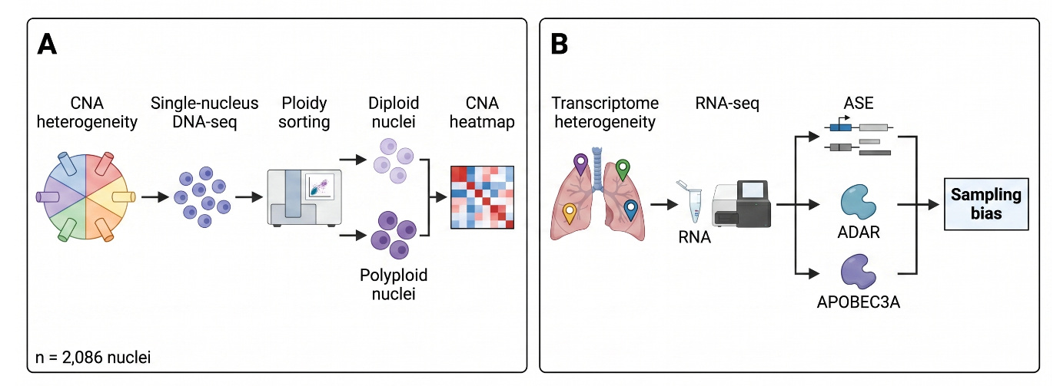
Figure 3. Genomic and transcriptomic sources of intratumour heterogeneity and associated technical limitations. (A) Single-nucleus DNA sequencing reveals copy-number alteration (CNA) heterogeneity and ploidy variation at single-cell resolution. (B) Transcriptomic heterogeneity arises from RNA-level processes including allele-specific expression (ASE) and RNA editing mediated by adenosine deaminase acting on RNA (ADAR) and apolipoprotein B mRNA editing enzyme catalytic subunit (APOBEC) enzymes, while sampling bias limits detection of spatially restricted subclones. Tumour ecosystem organisation and cell-cell interactions derived from single-cell transcriptomics further highlight functional heterogeneity across malignant, immune, and stromal populations. Adapted from ^{3,6,10}. Created in BioRender.com.

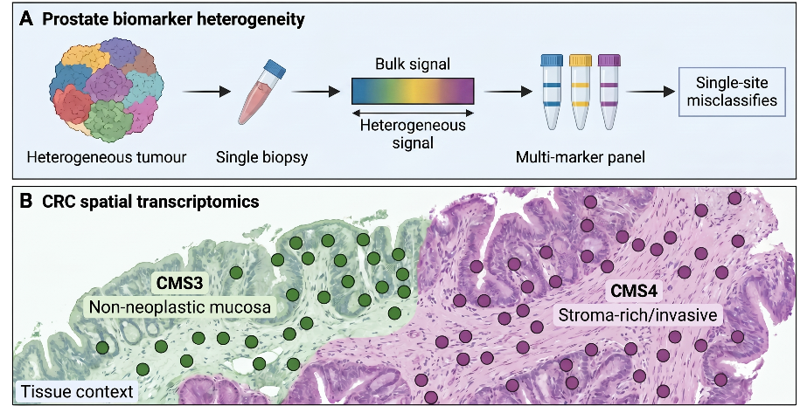
Figure 4. Clinical consequences of intratumour heterogeneity for biomarker reliability and spatial classification. (A) In prostate cancer, heterogeneous prostate-specific membrane antigen (PSMA) expression leads to discordance between bulk signal and single-biopsy sampling. (B) In colorectal cancer, spatial transcriptomics reveals compartment-specific consensus molecular subtype (CMS) localisation, demonstrating that bulk classification masks spatial heterogeneity. Adapted from ^{11,12}. Created in BioRender.com.

Table 1. Clinical trial strategies addressing intratumour heterogeneity through longitudinal and multi-omic profiling. These studies demonstrate a shift from single-biopsy analysis toward serial sampling, circulating tumour DNA monitoring, and integrated multi-omic approaches to improve detection of spatial and temporal tumour evolution. Trials are contextualised alongside published evidence demonstrating limitations of static genomic profiling and biomarker translation. Sourced from ^{14,19-22}.
NCT number | Tumour type | Title | Primary outcome measures | Sequencing-related outcome | Enrolment
NCT01414933 | Metastatic breast cancer | High Throughput Technologies to Drive Breast Cancer Patients to Specific Phase I or II Trials of Targeted Agents | Proportion of patients matched to targeted therapy based on molecular profiling | Integrated genomic profiling including comparative genomic hybridisation, sequencing, and gene expression analysis to identify heterogeneous driver alterations and resistance mechanisms | 423
NCT05303480 | Cutaneous T-cell lymphoma (mycosis fungoides) | Deep Phenotyping of Cutaneous T Cell Lymphoma, Type Mycosis Fungoides | Lesion severity (CAILS, mSWAT), objective response rate, quality of life | Multi-modal profiling including next-generation sequencing, immune profiling, and microbiome analysis to assess intra- and inter-patient heterogeneity | 32
NCT04008238 | Soft tissue sarcoma | Prospective Identification of Predictive Biomarkers of Trabectedin Efficacy in Non-L Soft-tissue Sarcoma Patients | Objective response or stable disease greater than 6 months | Longitudinal tumour and blood sequencing to identify dynamic biomarkers and temporal heterogeneity during treatment | 29
NCT06861647 | Ocular melanoma (uveal and conjunctival) | iSITE: Investigation of Somatic Alterations in Tumours of the Eye | Identification of somatic mutations and tumour evolutionary trajectories | Whole-genome and exome sequencing with longitudinal circulating tumour DNA analysis to track intratumour heterogeneity and mutation dynamics | 58
NCT01970865 | Non-small cell lung cancer (ALK positive or ROS1 positive) | Phase 1 and Phase 2 Study of PF-06463922 in Patients With Advanced Non-Small Cell Lung Cancer Harboring Specific Molecular Alterations | Dose limiting toxicity, objective response rate | Tumour tissue and plasma sequencing including circulating tumour DNA analysis to detect resistance mutations and clonal evolution under targeted therapy | 364
Abbreviations:
CAILS, Composite Assessment of Index Lesion Severity; mSWAT, modified Severity Weighted Assessment Tool; DNA, deoxyribonucleic acid; ctDNA, circulating tumour DNA; ALK, anaplastic lymphoma kinase; ROS1, ROS proto-oncogene 1.

- Dentro SC, Leshchiner I, Haase K, Tarabichi M, Wintersinger J, Deshwar AG, et al. Characterizing genetic intra-tumor heterogeneity across 2,658 human cancer genomes. Cell. 2021;184(8):2239-2254.e39. doi:10.1016/j.cell.2021.03.009.
- Jamal-Hanjani M, Wilson GA, McGranahan N, Birkbak NJ, Watkins TBK, Veeriah S, et al. Tracking the evolution of non-small-cell lung cancer. N Engl J Med. 2017;376(22):2109-2121. doi:10.1056/NEJMoa1616288.
- Martínez-Ruiz C, Black JRM, Puttick C, Hill MS, Demeulemeester J, Larose Cadieux E, et al. Genomic-transcriptomic evolution in lung cancer and metastasis. Nature. 2023;616(7957):543-552. doi:10.1038/s41586-023-05706-4.
- Martínez-Jiménez F, Movasati A, Brunner SR, Nguyen L, Priestley P, Cuppen E, et al. Pan-cancer whole-genome comparison of primary and metastatic solid tumours. Nature. 2023;618(7964):333-341. doi:10.1038/s41586-023-06054-z.
- Lei Y, Tang R, Xu J, Wang W, Zhang B, Liu J, et al. Applications of single-cell sequencing in cancer research: progress and perspectives. J Hematol Oncol. 2021;14(1):91. doi:10.1186/s13045-021-01105-2.
- Baslan T, Kendall J, Volyanskyy K, McNamara K, Cox H, D’Italia S, et al. Novel insights into breast cancer copy number genetic heterogeneity revealed by single-cell genome sequencing. eLife. 2020;9:e51480. doi:10.7554/eLife.51480.
- Lim SY, Lin Y, Lee JH, Pedersen B, Stewart A, Scolyer RA, et al. Single-cell RNA sequencing reveals melanoma cell state-dependent heterogeneity of response to MAPK inhibitors. EBioMedicine. 2024;107:105308. doi:10.1016/j.ebiom.2024.105308.
- Kim YS, Kim D, Park J, Chung YJ. Single-cell RNA sequencing of a poorly metastatic melanoma cell line and its subclones with high lung and brain metastasis potential reveals gene expression signature of metastasis with prognostic implication. Exp Dermatol. 2023;32(11):1774-1784. doi:10.1111/exd.14900.
- Zhang X, Peng L, Luo Y, Zhang S, Pu Y, Chen Y, et al. Dissecting esophageal squamous-cell carcinoma ecosystem by single-cell transcriptomic analysis. Nat Commun. 2021;12(1):5291. doi:10.1038/s41467-021-25539-x.
- Gavish A, Tyler M, Greenwald AC, Hoefflin R, Simkin D, Tschernichovsky R, et al. Hallmarks of transcriptional intratumour heterogeneity across a thousand tumours. Nature. 2023;618(7965):598-606. doi:10.1038/s41586-023-06130-4.
- Paschalis A, Sheehan B, Riisnaes R, Rodrigues DN, Gurel B, Bertan C, et al. Prostate-specific membrane antigen heterogeneity and DNA repair defects in prostate cancer. Eur Urol. 2019;76(4):469-478. doi:10.1016/j.eururo.2019.06.030.
- Valdeolivas A, Amberg B, Giroud N, Richardson M, Gálvez EJC, Badillo S, et al. Profiling the heterogeneity of colorectal cancer consensus molecular subtypes using spatial transcriptomics. NPJ Precis Oncol. 2024;8(1):10. doi:10.1038/s41698-023-00488-4.
- Zhang Z, Liu Z, Chen L, Wang Z, Zhai Y, Qian P, et al. Liquid biopsy-based accurate diagnosis and genomic profiling of hard-to-biopsy tumours via parallel single-cell genomic sequencing of exfoliated tumour cells. Anal Chem. 2024;96(36):14669-14678. doi:10.1021/acs.analchem.4c03462.
- André F, Bachelot T, Commo F, Campone M, Arnedos M, Dieras V, et al. Comparative genomic hybridisation array and DNA sequencing to direct treatment of metastatic breast cancer: a multicentre, prospective trial. Lancet Oncol. 2014;15(3):267-274. doi:10.1016/S1470-2045(13)70611-9.
- George J, Maas L, Abedpour N, Cartolano M, Kaiser L, Fischer RN, et al. Evolutionary trajectories of small cell lung cancer under therapy. Nature. 2024;627(8005):880-889. doi:10.1038/s41586-024-07177-7.
- Tirosh I, Izar B, Prakadan SM, Wadsworth MH 2nd, Treacy D, Trombetta JJ, et al. Dissecting the multicellular ecosystem of metastatic melanoma by single-cell RNA-seq. Science. 2016;352(6282):189-196. doi:10.1126/science.aad0501.
- Hausser J, Alon U. Tumour heterogeneity and the evolutionary trade-offs of cancer. Nat Rev Cancer. 2020;20(4):247-257. doi:10.1038/s41568-020-0241-6.
- Schmelz K, Toedling J, Huska M, Cwikla MC, Kruetzfeldt LM, Proba J, et al. Spatial and temporal intratumour heterogeneity has potential consequences for single biopsy-based neuroblastoma treatment decisions. Nat Commun. 2021;12(1):6804. doi:10.1038/s41467-021-26870-z.
- ClinicalTrials.gov. Deep Phenotyping of Cutaneous T Cell Lymphoma, Type Mycosis Fungoides (NCT05303480). 2023. Available from: https://clinicaltrials.gov/study/NCT05303480. Accessed 30 April 2026.
- ClinicalTrials.gov. Prospective Identification of Predictive Biomarkers of Trabectedin Efficacy in Non-L soft-tissue Sarcoma Patients (NCT04008238). 2026. Available from: https://clinicaltrials.gov/study/NCT04008238. Accessed 30 April 2026.
- ClinicalTrials.gov. iSITE: Investigation of Somatic Alterations in Tumours of the Eye (NCT06861647). 2026. Available from: https://clinicaltrials.gov/study/NCT06861647. Accessed 30 April 2026.
- ClinicalTrials.gov. Phase 1 and Phase 2 Study of PF-06463922 in Patients With Advanced Non-Small Cell Lung Cancer (NCT01970865). 2024. Available from: https://clinicaltrials.gov/study/NCT01970865. Accessed 30 April 2026.

